

ICT710 – Interaction Design and Usability
Assessment 3: Design Report
Trading Mobile Application

Shradhdha Neel Diyora | 65430
Hiren Kanubhai Italiya | 65564
Sneh Vijaybhai Bhikadiya | 66186

Table Of Content
1. Introduction 3
2. Design Process 4
2.1 Overview of Design Methodology 4
2.2 Key Insights from Assessment 2 5
2.3 Group Collaboration and Communication 5
3. Design Rationale 6
3.1 Theoretical Framework 6
3.2 Knowledge of the Design Process 6
4. User Interface Design 8
4.1 Design System and Visual Language 8
4.2 Key Screen Designs 8
4.2.1 Login & Onboarding Screen 8
4.2.2 Redesigned Dashboard (Home Screen) 9
4.2.3 Markets Screen 10
4.2.4 Transaction Screen (Buy/Sell) 11
4.2.5 Auto-Trading Wizard - Step 1: Strategy Templates 12
4.2.6 Auto-Trading Wizard - Step 2: Set Rules 12
4.2.7 Auto-Trading Wizard - Step 3: Review & Activate 13
4.2.8 AI Chatbot (Support Chat) 14
5. Usability Evaluation 14
5.1 Heuristic Evaluation 14
5.2 Projected Task Performance Improvements 15
5.3 Accessibility Evaluation 16
6. Conclusion 16
6.1 Summary of Key Findings and Design Outcomes 16
6.2 Assessment of Current Usability 17
6.3 Potential Impact of Recommended Improvements 17
6.4 Future Directions 17
References 18

1. Introduction

1.1 Project Overview
This is a continuation of the needs analysis and usability testing done in the assessment 2 of the Trading Mobile Application. The project is designed to provide a user-friendly and intuitive interface for a mobile trading platform that caters to a wide range of users, including novice traders and seasoned investors.

The Trading Mobile Application allows you to search for stocks and cryptocurrencies, place a buy or sell order, move funds from your bank account to your trading wallet, and set up auto-trading rules, as well as communicate with an AI-powered chatbot for instant support. The design process outlined in this report incorporates feedback from previous usability testing to create an interface that is both intuitive, accessible and refined.

1.2 Target Users
The application was created to cater to three main user groups:
- Beginner Traders – Users with lesser expertise in the financial field who need explanations, tooltips, and streamlined processes.
- Intermediate Investors – These users are with moderate experience and are interested in getting efficient transaction flows and real-time market data.
- Traders – Individuals who trade cryptocurrencies and need real-time updates on crypto prices, charts, and auto-trading features.

1.3 Design Goals
The key design goals for this iteration, based on the needs analysis and usability testing results are:
- Enhance navigation and make dashboard less complicated.
- Simplify transaction flows in the purchase, sale and transfer of funds.
- Enhance the auto-trading configuration by using guided templates and step-by-step instructions.
- Improve error reporting and feedback on confirmation of critical actions.
- Enhance the responsiveness and contextual directions of chatbots.
- Make it accessible by offering dark/light mode and text size options.

2. Design Process

2.1 Overview of Design Methodology
A User-Centred Design (UCD) approach was used during the design process. The user is at the heart of all design decisions at UCD, and the final product reflects the users' actual needs and expectations, not assumed needs and expectations [7]. The process was iterative and involved four phases:
- Discovery – Analysis of Assessment 2 results, pain points in usability and user needs.
- Ideation – Brainstorming, user flow mapping, and low fidelity wireframe sketching.
- Prototyping – High fidelity prototypes created in Figma and diagrams in Lucidchart and Visual Paradigm.
- Evaluation – Heuristic evaluation and review with Nielsen's usability principles [2].

2.2 Key Insights from Assessment 2
The needs analysis and usability testing in Assessment 2 showed that there were a number of critical usability issues, which directly influenced the redesign:

Usability Issue | Severity | Impact
Complex navigation structure | High | It was difficult to find Auto-Trading and features.
Inconsistent button placement | High | The "buy" and "sell" buttons were placed in various locations on the screens.
Information overload on dashboard | High | Too many charts/data resulted in confusion and delayed decision making.
Insufficient error feedback | Moderate | Users were not happy with unclear error message when transferring funds.
Chatbot limitations | Moderate | When the same answer was repeated, without any new information, there was a loss of trust in the tool.
No beginner onboarding | Moderate | New users had no idea of the trading vocabulary or trading processes.

2.3 Group Collaboration and Communication
We the team of three - Shradhdha, Hiren and Sneh, used messaging tools for real-time communication and discussion, and GitHub for version control and file sharing. The following is the distribution of task responsibilities:
- Shradhdha Diyora – Lead designer (Figma prototypes, needs analysis review, report writing).
- Hiren – User flow diagrams (Figma), design rationale, and usability evaluation.
- Sneh – Wireframe development (MockFlow), recommendations and visual design (Figma).

3. Design Rationale

3.1 Theoretical Framework
The redesign is based on the principles of interaction design:
- Norman’s Design Principles (2013): Affordances and signifiers are addressed in the redesign with all interactive elements clearly labelled and visually distinct. Feedback is enhanced so that users can always be aware of the result of an action [1].
- Nielsen's 10 Usability Heuristics: Heuristic 1 (Visibility of System Status), Heuristic 6 (Recognition over Recall), Heuristic 9 (Help Users Recognise, Diagnose, and Recover from Errors), and Heuristic 10 (Help and Documentation) are addressed [2].
- Shneiderman's Eight Golden Rules: Redesigned to make it more consistent across screens, less load on the user's memory, with informative feedback for all transactions [3].
- ISO 9241-11 (2018): The effectiveness, efficiency, and satisfaction of each user task is assessed for usability [5].

3.2 Knowledge of the Design Process

3.2.1 Simplified Dashboard
The original dashboard was cognitively overloaded with financial data on one screen, and was given an Ease of Navigation score of 3.5/5 and a Transaction Simplicity score of 3/5 in usability testing. The new dashboard has been designed to be progressive disclosure, displaying only the most crucial information (total balance, recent activity, quick action buttons) at first, and allowing users to click on the sections to reveal detailed information about the portfolio and charts [1], [4]. This is in line with Heuristic 6 (Recognition over Recall) and helps to avoid decision paralysis [2].

3.2.2 Consistent Navigation Structure
The menu system has been replaced by a consistent bottom navigation bar with five distinct tabs (Home, Markets, Portfolio, Alerts, and Settings) that are clearly labeled. All the main features can be tapped into from any screen within 2 taps. The Auto-Trading section, which was the least completed task in testing (60%), is now available straight from the Home dashboard and Markets tab. Buy/Sell button location is consistent throughout all screens.

3.2.3 Guided Auto-Trading Setup
The auto-trading setup took an average of 3 minutes 20 seconds to complete (lowest performance in testing) and has been redesigned with a step-by-step wizard interface. Users who are not familiar with these strategies can easily understand them thanks to pre-built strategy templates (DCA, Momentum Trading, Stop-Loss Protection) and their explanations in simple language. Custom rules can still be set for advanced users.

3.2.4 Improved Error Handling and Feedback
All error messages now contain a distinct description of what went wrong, the probable cause and a suggested solution. Transaction confirmation screens show an overview before any money is transferred, minimizing user mistakes. These changes directly address Nielsen's Heuristic 9, and are consistent with Shneiderman's rule of providing informative feedback [2], [3].

3.2.5 Enhanced Chatbot and Onboarding
The chatbot (3.6/5 user satisfaction) is enhanced with contextual awareness, meaning it can identify the screen the user is on and provide appropriate instructions. A new onboarding tour has been added, which shows the main features and trading concepts with short interactive tooltips [7]. This directly responds to the needs analysis of beginner traders.

4. User Interface Design

4.1 Design System and Visual Language
We created a consistent design system to maintain visual coherence across all screens:
Element | Specification | Rationale
Primary Colour | #1A73E8 (Blue) | Trust, reliability - typical in financial applications.
Secondary Colour | #34A853 (Green) / #EA4335 (Red) | Universal buy/sell signal colours for trading contexts.
Background | #0A0E1A (Dark) | Dark mode helps active traders reduce eye strain.
Typography | Inter / Roboto, 14–16pt body | High readability of text on mobile screens of many sizes.
Spacing | 8pt grid system | Applying the same alignment to content in all screen sizes.Using the same alignment for content in all screen sizes.
Iconography | Material Design icon set | Intuitive, familiar and universally recognised navigation icons.

4.2 Key Screen Designs

4.2.1 Login & Onboarding Screen
The logon screen has a clean, dark, minimalist design with the Trading App logo, username and password input and biometric logon support with an option to ‘New to trading? Click on the ‘Take a tour’ link, which will start a guided tour experience for first-time users. The screen is meant to build trust and reduce the entry barrier for the new users to the platform.
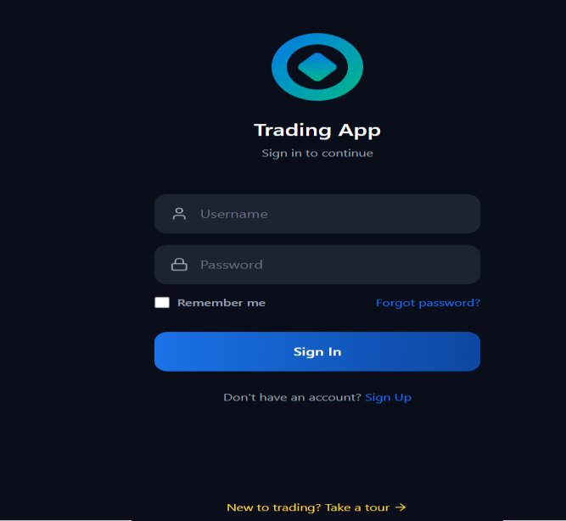
Figure 1. Login Screen – Trading Mobile Application (Designed using Figma)

4.2.2 Redesigned Dashboard (Home Screen)
The dashboard has been reorganised and given a clear visual hierarchy. The upper part welcomes the user by their name and shows the total value of the portfolio and the change per day. 4 fast action buttons (Deposit, Withdraw, Transfer, Receive) are available for instant access to the main functionality. There is a ‘Top Movers' section for key market updates and a collapsible Watchlist to decrease information density. A green floating ‘Buy/Sell’ action button offers a fast, easy-to-access option without having to leave home.
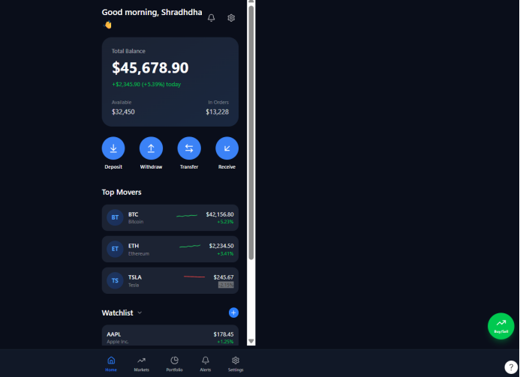
Figure 2. Redesigned Dashboard / Home Screen (Designed using Figma)

4.2.3 Markets Screen
Markets screen features a full width price chart with time ranges filters (1H, 1D, 1W, 1M, 3M, 1Y) and segmented control to navigate between Crypto and Stocks views. The logo, asset name, ticker, mini sparkline trend line, price and % change is displayed in each asset row and the colour is set to be green (positive) or red (negative). Quick asset lookup is available from the search button at the top right.
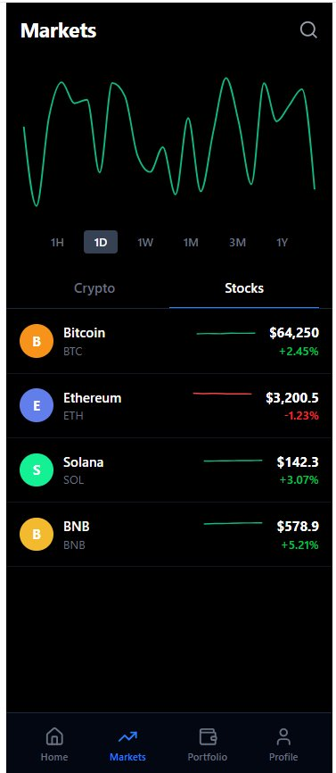
Figure 3. Markets Screen showing Crypto and Stocks views (Designed using Figma)

4.2.4 Transaction Screen (Buy/Sell)
The Buy/Sell screen features a standardised tabbed interface with Buy and Sell always visible at the top. When you click on the asset selector, it shows the current asset and price. A large button that says ‘Entry Field’ and has a button named ‘MAX’ is followed by a large button that reads ‘Review Order', and underneath it, there is a large amount entry field with a live fee calculator of 0.1% fee. This two-step confirmation process (entry → review → confirm) helps to avoid any accidental transactions and enhances user trust.
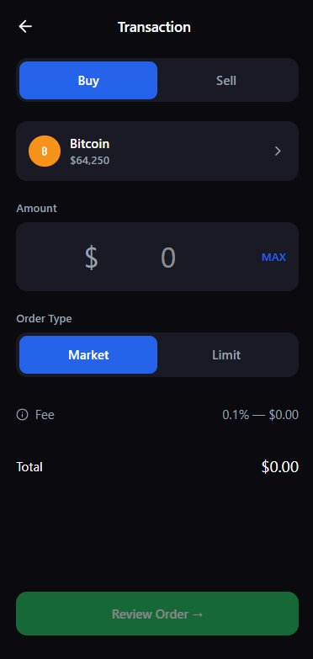
Figure 4. Transaction (Buy/Sell) Screen with Review Order flow (Designed using Figma)

4.2.5 Auto-Trading Wizard - Step 1: Strategy Templates
In Step 1 of the Auto-Trading wizard, there are three pre-built strategy templates, each with a description in plain language and a ‘Use’ button. A step progress indicator is at the top to help users stay oriented (‘Step 1 of 3’). By using this template-first approach, the technical complexity is eliminated from the tasks to solve the problem of only 60% of students completing the tasks in the Assessment 2.

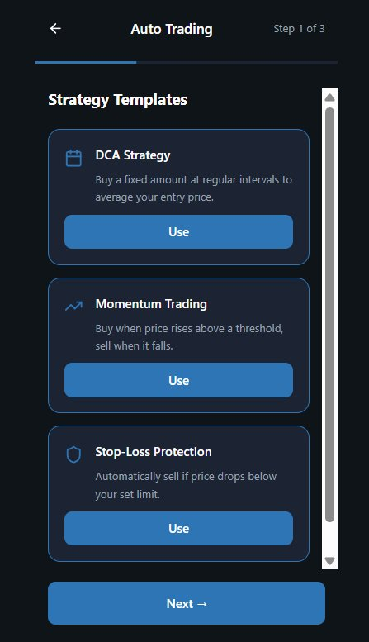
Figure 5. Auto-Trading Wizard – Step 1: Strategy Templates (Designed using Figma)

4.2.6 Auto-Trading Wizard - Step 2: Set Rules
This step will enable you to specify the rules for your auto-trade. In Step 2, users can set up their trading rules: Buy Trigger price, Sell Trigger price, Max Amount, trading Interval (Daily/Weekly/Monthly). There is a ‘?’’ tooltip icon in each field for on-the-fly assistance. The clean form layout with large input fields decreases the risk of input errors and gradually leads the users through the configuration system.
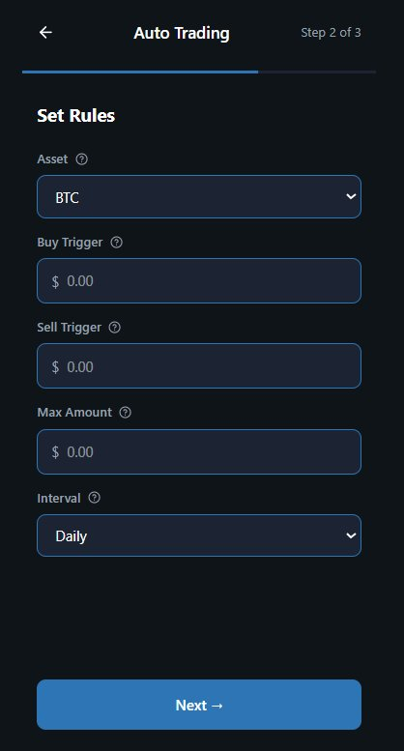
Figure 6. Auto-Trading Wizard – Step 2: Set Rules (Designed using Figma)

4.2.7 Auto-Trading Wizard - Step 3: Review & Activate
Step 3 displays a clear 2-column card with all the strategy settings, including Strategy type, Asset, Buy Trigger, Sell Trigger, Max Amount, and Interval, configured. The ‘Activate immediately’ toggle (default ON) provides control to the user. The final step is the green ‘Activate Auto-Trading’ button. This confirmation step is consistent with Shneiderman's guideline: provide closure and informative feedback [3].
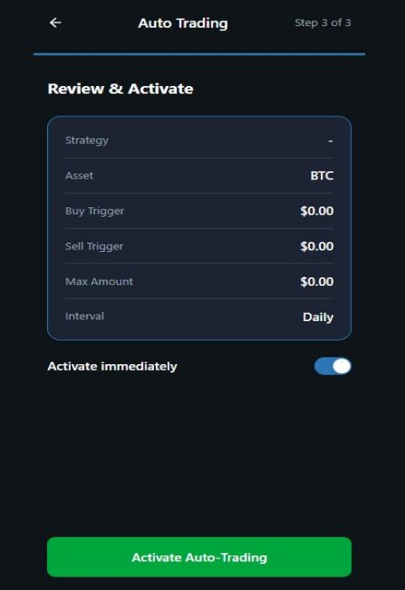
Figure 7. Auto-Trading Wizard – Step 3: Review & Activate (Designed using Figma)

4.2.8 AI Chatbot (Support Chat)
The Support Chat screen has a chat-like UI that displays the bot's messages as dark rounded bubbles to the left, while displaying user's messages as blue rounded bubbles to the right, with time stamps. A typing indicator (animated dots) shows when the bot is processing. Quick-reply suggestion chips are located at the bottom of the page and offer context-sensitive shortcuts, such as 'What is auto-trading?', ‘How do I buy BTC?'. There is a human-agent escalation icon in the top right that can be used to escalate complex issues.
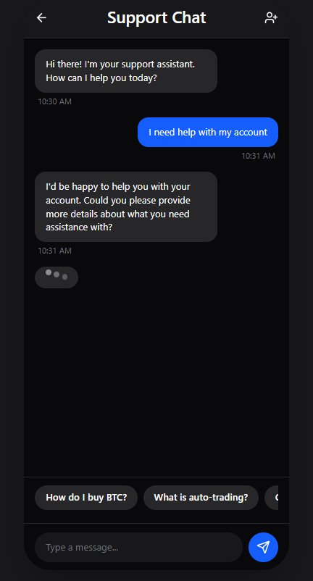
Figure 8. AI Chatbot / Support Chat Screen (Designed using Figma)

5. Usability Evaluation

5.1 Heuristic Evaluation
By the three members of the group, the redesigned prototype was examined with respect to Nielsen's 10 Usability Heuristics [2]:
Heuristic | Finding | Status
1.Visibility of System Status | Added loading states, transaction progress bar and confirmation screen. | Resolved
2. System and Real World match | Financial terms explained in simple terms; labels throughout the book in plain language. | Resolved
3. Control and freedom of the user | All transaction flows have undo/cancel options. | Resolved
4. Consistency and Standards | All screens use the same button location, icon set and Colour coding. | Resolved
5. Error Prevention | Asks for confirmation before irreversible operations (transfers, sells). | Resolved
6. Recognition over Recall | There is no hidden menus for primary functions and it is easy to see from the dashboard. | Resolved
7. Flexibility and Efficiency | There is expert mode for the advanced user in addition to the simplified templates. | Resolved
8. Aesthetic & Minimal Design | The progressive disclosure feature minimizes driver distractions on the dashboard. | Resolved
9. Assist Users to Overcome Errors | Comprehensive, correct and helpful error messages and hints for solving errors. | Resolved
10. Help and Documentation | New features include onboarding tour, contextual tooltips and enhanced chatbots. | Resolved

5.2 Projected Task Performance Improvements
Based on the design changes made, the following improvements were projected in task completion rates and times:
Task | Original Rate | Original Time | Projected Rate | Projected Time
Search Cryptocurrency | 100% | 35 sec | 100% | 20 sec
Buy Cryptocurrency | 90% | 1 min 40 sec | 95% | 55 sec
Sell Stock | 80% | 2 min | 92% | 1 min 10 sec
Transfer Funds | 70% | 2 min 30 sec | 90% | 1 min 20 sec
Setup Auto-Trading | 60% | 3 min 20 sec | 85% | 1 min 50 sec
Chatbot Interaction | 90% | 50 sec | 95% | 35 sec
Both the Auto-Trading setup (60% to 85% completed) and the Transfer Funds (70% to 90% completed) tasks were the two highest priority tasks in Assessment 2 testing, and both have the greatest projected improvements.

5.3 Accessibility Evaluation
The new interface has been tested for WCAG 2.1 compliance:
- All text elements have a colour contrast ratio of at least 4.5:1 that complies with AA standard.
- All interactive elements have a minimum touch target size of 44x44pt, meeting Apple HIG and Google Material Design guidelines [6].
- Dark mode is supported 100%, colours are optimized to keep all contrast ratios in both modes.
- The text can be enlarged or shrunk by changing accessibility settings on the device, without affecting the interface layout.
- All images and icons have alternative text to make them screen reader friendly.

6. Conclusion

6.1 Summary of Key Findings and Design Outcomes
This design report is a detailed redesign of the Trading Mobile Application, directly following the usability issues found in the Assessment 2 report. All five major usability issues identified in the study and presented in the evaluation, namely complex navigation, inconsistent button placement, information overload, inadequate error feedback, and chatbot limitations, are addressed in the redesign with evidence-based design decisions, based on the existing frameworks in HCI [1], [2]. [3], [4].

The main design features are: Standardised navigation structure that can be accessed in two taps, Guided auto-trading wizard (6 steps reduced to 3 guided steps), Error message improved, Transaction confirmation improved, Enhanced contextual Chatbot with quick-reply chips, Full onboarding support for beginner traders.

6.2 Assessment of Current Usability
In assessment 2 testing, the overall satisfaction rating was 3.7/5 and the SUS score was 78.5 for the original application. This is a border line acceptable usability, but there are still a lot of gaps, especially in transaction flows (3/5) and how easy it is to navigate (3.5/5). Based on the heuristic evaluation and comparative task analysis, the ratings are expected to be 4.2-4.5/5 on these dimensions for the redesigned prototype.

6.3 Potential Impact of Recommended Improvements
The expected outcomes of implementing the recommended design changes are that there will be an increase in the overall completion rates of tasks from an average of 82% to 93% or higher, a reduction in average task completion time from approximately 35-45%, and an increase in user satisfaction scores from 3.7/5 to 4.3/5. These enhancements should help lower user frustration and drop-off, build user trust in the platform, and boost user retention.

6.4 Future Directions
Future research and development should involve:
- Formal usability testing of redesigned prototype with larger and more diverse sample of participants (n=30+) to validate anticipated improvements.
- Competitive usability analysis with other popular trading apps (such as eToro, Robinhood, CommSec Pocket) to compare performance.
- A/B testing progressive disclosure dashboard vs full data dashboard to find out which is preferred by user based on experience.
- Longitudinal user studies to evaluate if improvements to the onboarding tutorials and chatbot result in long-term improvements in task performance.
- Continuous enhancement of AI chatbot functionalities, such as connecting with real-time market data for personalized trading insights.

References
- D. Norman, The Design of Everyday Things, Revised and Expanded Edition. New York, USA: Basic Books, 2013. [Online]. Available: https://www.basicbooks.com/titles/don-norman/the-design-of-everyday-things/9780465050659/

- J. Nielsen, "Usability 101: Introduction to Usability," Nielsen Norman Group, 2012. [Online]. Available: https://www.nngroup.com/articles/usability-101-introduction-to-usability/

- B. Shneiderman, C. Plaisant, M. Cohen, S. Jacobs, N. Elmqvist and N. Diakopoulos, Designing the User Interface: Strategies for Effective Human-Computer Interaction, 6th ed. Pearson, 2016. https://www.pearson.com/en-us/subject-catalog/p/designing-the-user-interface/P200000003054

- A. Dix, J. Finlay, G. Abowd and R. Beale, Human-Computer Interaction, 3rd ed. Pearson Education, 2004. https://www.pearson.com/en-gb/subject-catalog/p/human-computer-interaction/P200000005000

- ISO 9241-11, Ergonomics of Human-System Interaction – Usability: Definitions and Concepts, International Organization for Standardization, 2018. [Online]. Available: https://www.iso.org/standard/63500.html

- W3C, "Web Content Accessibility Guidelines (WCAG) 2.1," World Wide Web Consortium, 2018. [Online]. Available: https://www.w3.org/TR/WCAG21/

- J. Garrett, The Elements of User Experience: User-Centered Design for the Web and Beyond, 2nd ed. New Riders, 2011. https://www.newriders.com/9780321683687

